Book-Talk
SELF-REFLECTION

“Follow effective action with quiet reflection. From the quiet reflection will come even more effective action.”
-Peter Drucker (American educator and writer)

Today you have the unique opportunity to see yourself through the eyes of others. You will learn about your strengths and weaknesses through this process. You will watch your book talk presentation and evaluate yourself using the rubric on the back of this page. What grade do you think you earned? Base your grade on how well your presentation met the standards outlined on the rubric. After totaling up your score and before seeing the score you received from the teacher, type out a reflection.
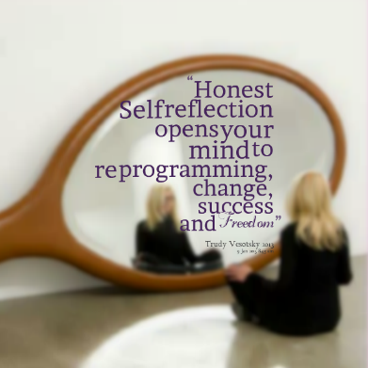
This reflection will be due on NOVEMBER 3rd.
Directions: Type a reflection AFTER viewing your presentation and totaling the grade on the rubric (back)

- Type your full class heading at the top
(Your Full Name, Date, Assignment, Teacher/Class Period)
- Type a well-developed paragraph reaction/reflection to the viewing of yourself.
Be sure to use proper paragraph format (topic sentence, details, concluding sentence).

Address ANY THREE of the following in the reflection paragraph:

- One of the strengths of your presentation
- One of the weaknesses of your presentation
- Something you didn’t realize about yourself before / Something you learned about yourself (AHA Moment)
- Something that you will try to work on in the future
- Something that you did this time and will continue to do in future presentations

- Spell-check and proofread your work.
- Attach the Public Speaking Self-Evaluation Rubric to the back of your essay
- Due on November 3rd.

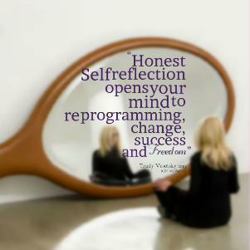
Public Speaking
Self Evaluation Rubric

VOICE | Always | Sometimes | Rarely
- The speaker could be heard easily  - The speaker spoke slowly and clearly  - The speaker refrained from using “um,” “uh,” “like,” “and” etc. | 10 | 7 | 4-0

POSTURE
- The speaker stood steady (no swaying)  - His/her hands were still (but not in his/her pockets) | 10 | 7 | 4-0

EYE CONTACT
- The speaker had natural & appropriate eye contact with the audience | 10 | 7 | 4-0

BODY LANGUAGE
- S/he was enthusiastic and made an attempt to engage the audience | 10 | 7 | 4-0

ORGANIZATION
- Introduction grabbed the attention of the audience, transitions provided a logical flow, and the conclusion provided a satisfying closure | 10 | 7 | 4-0
CONTENT | Excellent | Good | Poor
- Knowledge of literary categories (Fab 5) complete & thorough | 20 | 15 | 7-0
- Specific text-based details as support/evidence | 20 | 15 | 7-0
- Effort & creativity reflects depth of thought, planning, and originality. Lesson choice is interesting, appropriate, and fits section mood | 10 | 7 | 4-0

